CHAPTER 3
SYSTEM ANALYSIS AND DESIGN

This project's chapter introduces an incremental approach to problem-solving for smart campus environments. It describes the methodology applied for the project, identifies the functional requirements of the system following an analysis of the current operational systems. The following sections comprise the system analysis and design chapter: System Analysis, Design of the Proposed System, Data Collection, and Research Methodology.

3.1 SYSTEM ANALYSIS
This section examines the existing campus navigation challenges faced by students, staff, and visitors. It includes an analysis of current solutions, their limitations, and the identification of key user needs that the Smart Campus Navigator aims to address.

3.1.1 ANALYSIS OF THE EXISTING SYSTEM
Versatility of Applications
Current campus navigational solutions are used not only for wayfinding by people but also for class scheduling, resource management, and emergency coordination, among other applications. All these wide uses call for a flexible and complete navigation system.

Integration with Wearable Technology
New navigation solutions now operate with wearable devices such as smartwatches and AR glasses. This combination indeed gives a smooth and engaging experience by offering real-time, hands-free help with information. It would really enhance the Smart Campus Navigator if such a wearable could be integrated to make accessing and interacting even easier upon the users.

User-Centered Learning
Schools are increasingly applying AR technologies and smart navigation systems into the process of creating interactivity and student-oriented learning. These technologies create immersive simulations and provide better learning experiences, allowing the student to be more engaged in what they are learning. Smart Campus Navigator purports to get improved experiences by providing the right navigation and information that complements each student's learning journey.

Indoor Wayfinding
Strong navigation with augmented reality features in any big school or campus should be inside. Applications with current AR features help and provide clear directions inside a building to facilitate searching for classrooms, offices, and so on. It is only where Smart Campus Navigator seeks to enhance tools with powerful indoor navigation features so that users of a campus can easily move.

Collaborative Augmented Reality
Platforms utilizing collaborative technologies in AR show that users can interact with others and perform better. When using collaborative technologies, these platforms allow shared experiences and real-time teamwork among students in campus communities. Smart Campus Navigator plans to offer collaborative AR tools to support group projects, event planning, and social interactions in communities on college campuses.

Commercial Implementation
Those are good examples of increasing acceptance and usability, with massive commercial deployment taking place for both augmented reality navigation technologies and popular Google Maps applications. These successful implementations have thus become the yardsticks of references in developing user-centric, intuitive navigation systems. This tries to do the same toward providing campus-wide, best-practical, reliable, and engaging navigation experiences.

Challenges
Despite this, many challenges still exist even in the technologies used for navigation. User acceptance and privacy issues are major surrounding data collection and implementation. In addition to that, effectiveness in navigation technology relies heavily on the quality of mapping information. Smart Campus Navigator will address these challenges through fulfilling promises for user privacy, ensuring mapping is accurate, and maintaining interaction where feedback from the jurisdiction is applied.
3.1.1 Limitations of the Existing System
Accuracy and Precision
Challenge: Particularly in dynamic situations, and amidst change, achieving high levels of accuracy and precision in navigating with mobile AR within a given campus environment poses challenging tasks.
Implications: Poorly placed augmented information can lead to user confusion and, consequently, navigation errors; in addition, it degrades the reliability and effectiveness of human-oriented systems.

Environmental Dependence
Disadvantages: Most mobile AR depends on environmental factors, ranging from lighting to some recognizable features for marker-based tracking, or GPS signal strength.
Consequences: This means that tracking of the user's position may be particularly weak in areas with bad lighting or a lack of distinctive features, especially in indoor and more crowded parts of the campus.

Hardware and Battery Limitations
Challenge: Mobile AR applications consume lots of power and processing power, especially over prolonged use.
Implication: Due to the limited battery life and device capabilities, mobile AR navigation systems lack practice in functionality and the extent of their use.

Privacy Concerns
Challenge: Mobile AR systems require access to personal data, such as location information, which is a primary privacy concern for end-users.
Implications: Specific concerns regarding perceptions related to privacy and misuse of information can also serve to discourage the use and adoption of AR mobile navigation systems.

Challenging User Interfaces
Problem: Developing a user-friendly interface for navigation through AR on mobiles is an uphill task.
Implications: A very crowded and heavy interface will push off possible users, especially those who are not fans of technology.

Limited Field of View (FOV)
Limitation of loss view hence only a little amount of data overlay can be displayed at a time.
This comes with implications for the users' experience and for the depth to which AR is integrated with the total system.

Adoption Barrier
Challenges: The cost and availability of mobile devices for running AR applications and the learning inertia associated with new technologies can inhibit the adoption of mobile AR.
Implications: These hurdles might result in low reasons for mobile AR navigation solutions to be taken up to consequently low levels of widespread use.

Data Accuracy and Maintenance
Challenges: AR mobile systems are highly dependent on the correctness and recentness of the map data.
Implications: Such data are not easily navigated due to either inaccuracy or being out-of-date. Updating data demands continuous updating, consuming expensive resources.

Distraction and Interruption
Challenge: The additional information for augmented reality in mobile devices may distract or interrupt the person using them.
Implications: The safety and situational awareness of the user depend on an effective tradeoff between the augmented content and the real world.

Issues in Accessibility
Challenge: Mobile AR applications may not be accessible to all, and particularly for users with disabilities.
Implication: It would need to address specific issues of access as well as provide other ways to navigate those with visual or motor impairments.
3.1.3 Justification of the New System
The "Smart Campus Navigator: A Mobile App for Nile University" project brings a novel approach in which a newcomer or a person who is difficult to guide through a very big and busy campus can have a guide very easily and smoothly. Strong reasons that really go with the goal and plans of this project are:

To design an interactive campus map that will display real-time information.
Current navigational systems do not further include interactive, real-time, campus maps that are updatable. The addition to features of the Smart Campus Navigator literally displays a map updating in real-time for easier building and facility recognition, together with attractive points of interest. The real-time variables of this update most highly promote navigational experience with respect to information accuracy and currency.
Most current systems usually support general navigation directions which, however, might not satisfy the unique requirements of different users. For example, the Smart Campus Navigator will give personalized directions for walking and driving, ensuring that everyone gets the best routes compatible with his/her ways of travel. All this will be done through personalization, and this will increase efficiency and user happiness.

Real-Time Tracking Events
Real-time monitoring of events and venues changes is a critical drawback of current systems. The Smart Campus Navigator will have real-time capabilities for monitoring events, such that the user is aware of what activities are going on in real time, and what changes in the events or activities can be reflected. This functionality keeps everyone involved and up to date about significant events happening on campus.

Accessibility Features
Current navigation systems often do not have strong accessibility features, which makes them harder to use for people with visual impairments. The Smart Campus Navigator will focus on being inclusive by adding voice-guided navigation and voice commands, making the system easy for everyone to use. This focus on accessibility means that everyone can use the navigation system, no matter their abilities.

Easy Inclusion of Accessibility Features
Now it is the system itself that will ensure the accessibility features match the primary function of the application. Such a global approach provides an overall facility and consistency with everybody that leads to bringing more people to use and enjoy it.

Assistance in Office and Staff Access
The Smart Campus Navigator is a tool that assists its users in looking for offices and staff members on a growing campus. Users can search for a name, and the system will provide information such as the user's job title, the building they are in, and the room number. These ease acquiring services by any individual, such as a visitor, parent, or even new student, inside the university campus.

Promoting Inclusivity and Accuracy
The new system will use information from users to keep an accurate campus map. This means the system will always be updated based on what users say. This encourages inclusivity and makes sure the app is dependable and useful. Also, the app will work offline, allowing map access without the internet, so users can navigate without interruption.

Enhancing Campus Connectivity
Smart Campus Navigator will incorporate a link between campus services, which include a library and dining, and users in a real-time manner. Such coordination will help users make better choices, and it will enhance their campus life.

Facilitating Use in Offline Mode
The Smart Campus Navigator is presented with offline features that allow for the map of the campus and other navigation tools to be accessed without having the need to connect to the Internet, in places with poor access to internet service. The Smart Campus Navigator focuses on meeting the goals of improving how people get around the campus, making things better for users, and accessibility to all.
3.1.4 Description of the New System
The Smart Campus Navigator: Context Aware Mobile App for Navigation in Nile University aims at developing a mobile application to facilitate navigation in the university campus for students, visitors, and staff. The system utilizes advanced technologies, including augmented reality, real-time data integration, and crowd-sourced information in providing a seamless and user-friendly navigation solution. This mobile application aims to break the limitations of current navigation schemes and provide an all-inclusive tool for efficient campus exploration.

Core Features:
1. Dynamic, Real-Time Interactive Campus Map
The application will feature a real-time, dynamic campus map that automatically gets updated with the latest additions and changes to campus facilities. It provides detailed, precise, and current information for easy location of buildings, facilities, and other places of interest.

2. Tailored Directions
The app creates personalized instructions for each pedestrian and driver. Through multi-modal movement accommodation, the app allows the most optimized routing that has the purpose of making campus navigation efficient relative to its feeling.

3. Real-Time Tracking of Events
Real-time event monitoring within the system keeps the users current with activities that are occurring, scheduling changes, and status of various events. The fact that push notifications are available keeps the user posted real-time about events on campus.

4. Accessibility Features
To enhance inclusion, the app adopts robust accessibility features such as voice guided navigation and voice commands. The features are meant to make the app useful for students and staff with visual impairments and to guarantee that everyone at the campus will be able to use the app.

5. Excellent Implementation of Accessibility Aspects
These accessibility features are integrated into the basic functionality of the applications themselves, ensuring a smooth user experience for everyone. This kind of integration assures that the app's accessibility is part of its design and not an add-on.

6. Supporting Office and Staff Navigation
The Smart Campus Navigator makes it simple to locate offices and personnel on campus. It allows users to search for the name of the person they wish to see and provide information regarding their role, building, and room number, making it convenient to find one's way to individual offices.

7. Crowd-Sourced Data for Accuracy
The application uses crowd-sourced data to have an up-to-date campus map. Users can give feedback and update the system to make the information up to date and reliable. This collaborative approach enhances the accuracy and relevance of the navigation system.

8. Offline Functionality
Since it is expected that there may be a need for continuous access, the required elements of the assignment can be accessed without the Internet through the Offline functionality of the Smart Campus Navigator. This system is still accessed anywhere the Internet connection is poor.

9) Integration with Campus Services
The application is integrated with the important services on the campus, like libraries and dining facilities, and gives all updates on it in real time. This feature helps in better decision-making by the user and a better overall experience on the campus.

10. Artificial Intelligence-Based Recommendations
The system deploys artificial intelligence for a smart recommendation of the best routes along with events relevant to user taste. This is custom level personalization of campus navigation for the user according to his needs.

11. Module for Feedback and Interaction
This module provides opportunity for users of the system to air their feedback on the performance of the system and the issues they find. It enables interactivity on asking questions, providing ratings, or even telling their experience when navigating, thus fostering user-centered interactions in their pursuit of continuous improvement.

12. Security and Privacy Module
Location data being sensitive, it has various modules dealing with security and privacy to protect the information of those who are using it. It includes encryption, access control, and privacy regulations to make sure all the components of the user data are secure and confidential.

13. Maintenance and Updates Module
The maintenance and updates portion ensures the system's ongoing functionality and accuracy. It includes procedures for changing map data, improving algorithms, and correcting issues discovered through user input. This portion plays a critical part in ensuring the system's reliability and currency.

3.2 DESIGN OF THE PROPOSED SYSTEM
This section of the chapter will introduce the techniques and activities needed to be carried out to have a better understanding of the new system’s Implementation. The System design begins with gathering user needs and modelling them using UML diagrams like using case and class diagrams to gain a better understanding of the system from the viewpoint of the user. One notation that is thought to be easier to use and more comprehensive is the UML notation.

3.2.1 Data Model
The diagram below is the entity relationship diagram of the system.
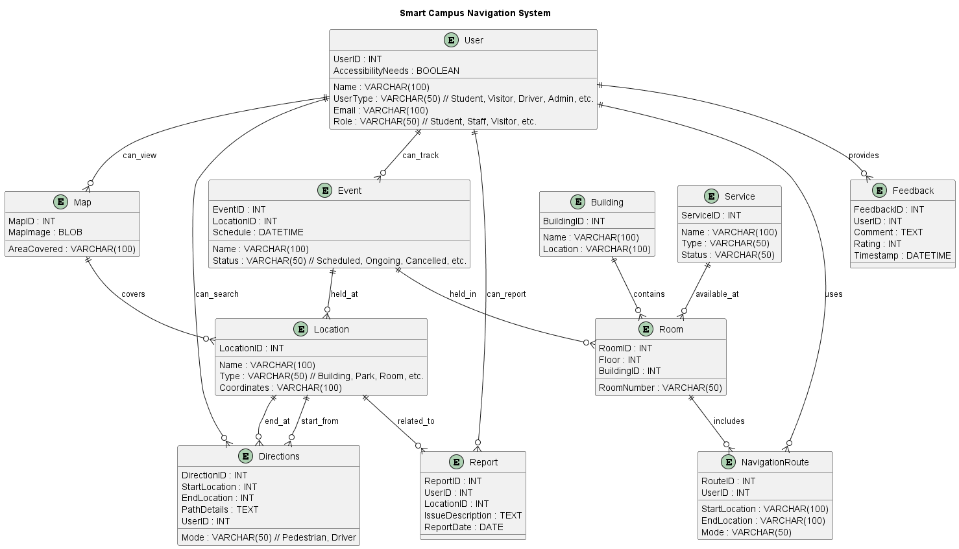

ENTITY RELATIONSHIP DIAGRAM

3.2.2 Functional Requirement (Use Case Diagram)
A use case illustrates the system's functional analysis. To understand the essential features and use cases related to the requirements that were identified, requirements analysis was conducted using use case diagrams. A use case diagram merely shows the system from the viewpoint of an external party, like a user. Actors, use cases, associations, and the system boundary are the four parts of a use case diagram.
In the Smart Campus Navigator system, students, visitors, drivers, and users with visual impairments are the primary users, while the system is overseen by the administrator. Additionally, maintenance staff and event organizers play vital roles. The way various users interact with the system is shown in the case diagram below.
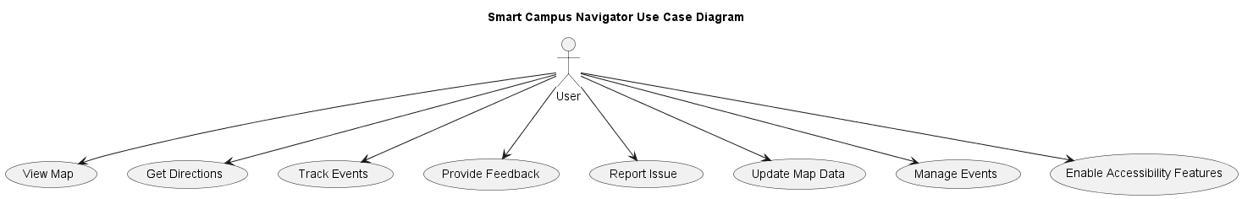

3.2.3 System Architecture (Deployment Diagram)
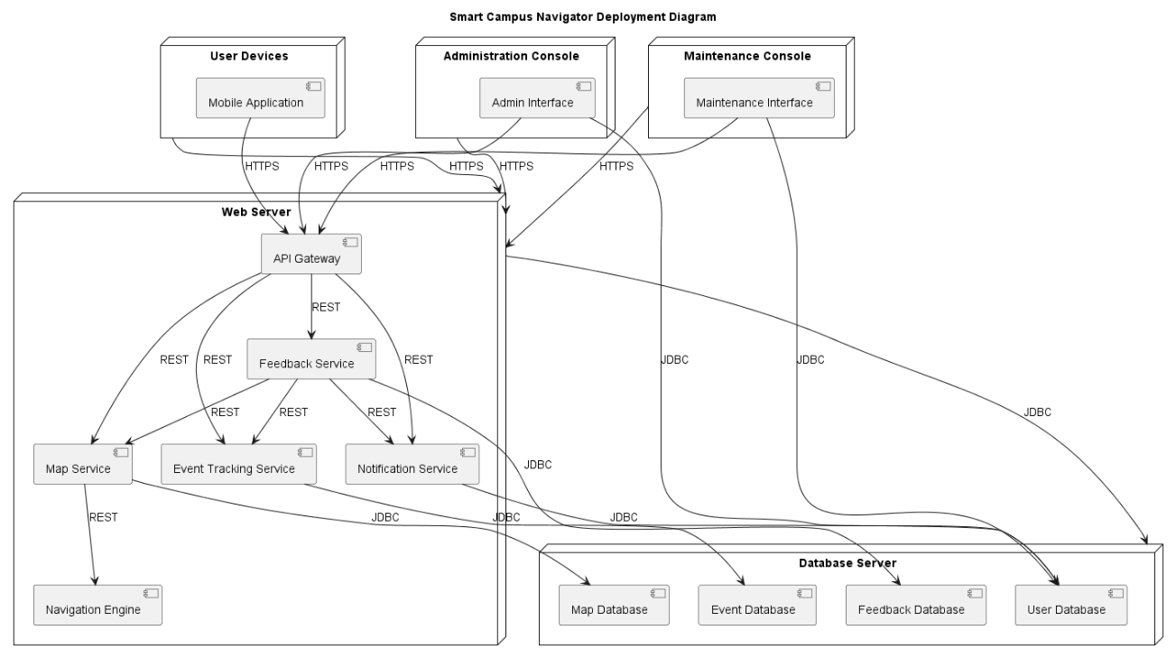
The diagram below shows the deployment of the system

DEPLOYMENT DIAGRAM

3.2.4 Software Structure (Class Diagram)
This class diagram depicts the system's various object classes, as well as the relationships between them.
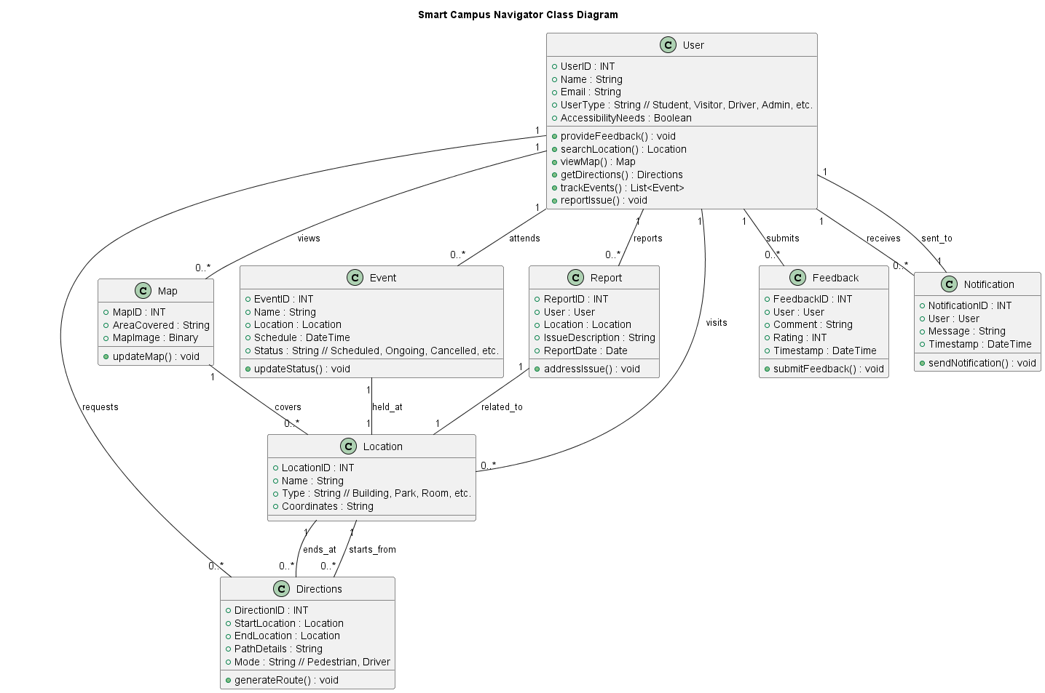
CLASS DIAGRAM

3.2.5 Workflow of Use Cases (Activity Diagram)
The system's activity flow is shown in the activity diagram. It shows how different actions taken by system entities flow graphically. All the scenarios that a system user can execute following a successful login are shown in this activity diagram.
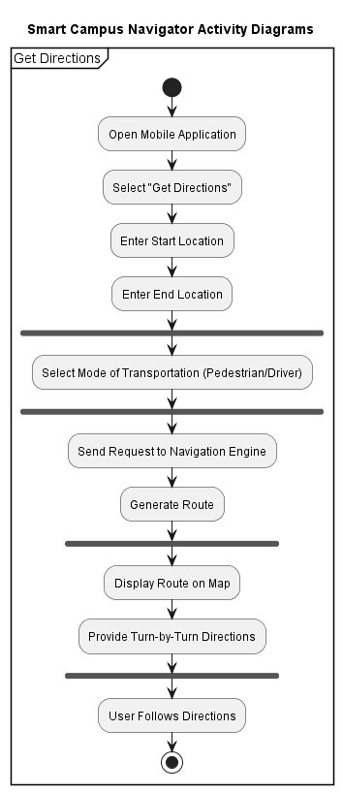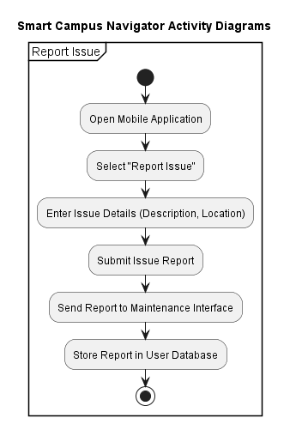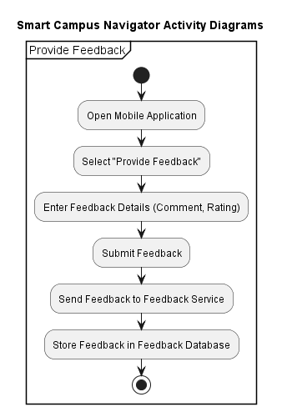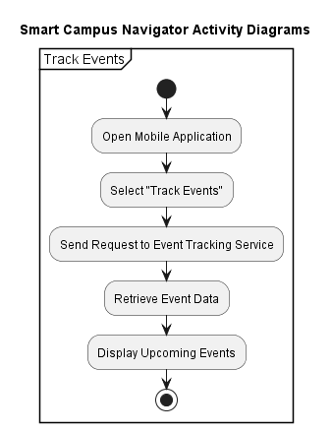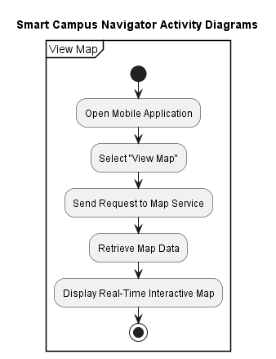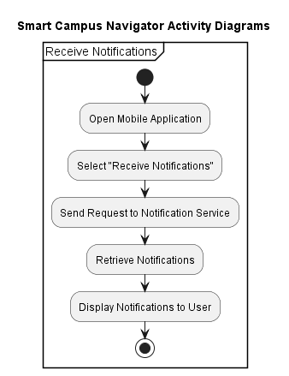
ACTIVITY DIAGRAM

3.3 Research Method
This research was executed through a qualitative approach for an in-depth investigation and understanding of the experience and responses of the current campus navigation system by the users. It would collect more information on the users' experience/attitude and opinions towards the system, which shall in turn give direction towards the development of the new Smart Campus Navigator.
The approach selected to achieve the goal was Rapid Application Development. RAD is a flexible software development method that lays more emphasis on quick, iterative prototyping. It is a very suitable approach for projects that demand fast development and frequent user feedback. It allows changes and flexibility in the development, ensuring the final product is much more in tune with users' needs and expectations.
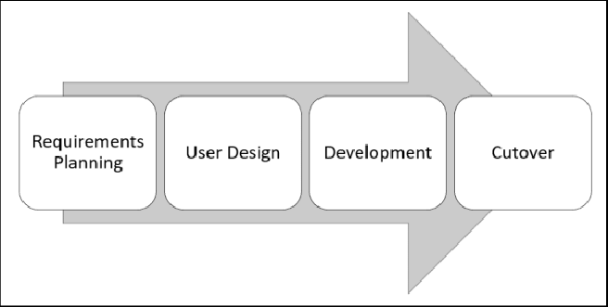
METHODOLOGY DIAGRAM

The Rapid Application Development (RAD) methodology adheres to a cyclical development approach encompassing several distinct phases.

RAD Model Flow
1. Planning Requirement
During this preliminary phase, the collection of requirements is conducted via workshops, focus groups, and stakeholder interviews, which include students, staff, and visitors. This collaborative methodology guarantees a comprehensive understanding of system requirements that are in accordance with user needs. The information obtained is utilized to delineate the project's scope and objectives.

2. User Design
At this stage, the team works very closely with end users on prototype creation and refinement. Prototyping is done in an iterative manner, where feedback from the users drives each increment. This is when system design and functionality can be visualized by constructing mock-ups, wireframes, and interactive prototypes. Ongoing user participation in the process ensures the design will be user-conscious and meet the user's expectations and needs.

3. Construction
In this phase, the system the real one begins its concrete evolution. Prototypes lead to implementable components. Functional implementation of the features and functionalities defined at the time of user design is accomplished through effective collaboration of developers and designers. Regular testing and validation with users ensure that the system is really being implemented to the specified requirements and that the emerging issues or improvements are worked out with speed.

4. Cutover
The last phase involves system integration, testing, and deployment. The system is thoroughly tested to check if it functions well and meets the performed standard. Users are trained to get accustomed to the novel system. Once done, the system is deployed for universal use. Ongoing support and maintenance are provided to facilitate handling issues and guarantee continuous improvement regarding feedback forwarded from the users.

3.4 Data Collection
To ensure the satisfaction of its intended users, the Smart Campus Navigator system was developed using extensive data collection methods. This is a strategic approach. Methods included online questionnaires, focus group talks, observational studies and review of literature.

A combination of online questionnaires and qualitative data were collected from students, staff, and visitors. Both open-ended and closed-end questions were included in the questionnaires to capture user feedback, challenges, and preferences related to campus navigation. The use of online questionnaires is due to their efficiency and affordability. Anonymity is a plus, and it can improve response rates, and the quality of data collected. Google Forms were utilized to design and distribute the questionnaire, which were also sent to selected respondents via email and shared on social media platforms like university community WhatsApp groups. The standardization of questions facilitated the comparison of answers, leading to more meaningful conclusions.

The focus group discussions were a way to get an interactive, deep dive into user experiences. A variety of stakeholders, including students and faculty as well as the administration, were involved in these discussions which provided valuable insights into group dynamics throughout the project, collective issues and potential solutions. The qualitative data collected from these sessions was a complement to the quantitative data obtained from the questionnaires, providing broader insights into user preferences.

Additionally, observational studies were conducted to obtain firsthand accounts of on-campus navigation behaviors. Researchers analyzed the way in which students, staff, and visitors move around campus, recording commonly used routes, navigation equipment, as well as obstacles encountered. By incorporating these observations, the system's design was informed on how it could be improved.

The literature was extensively examined to gather data on current systems that have tackled comparable navigation issues. A systematic review was conducted using academic papers, technical reports, and case studies to document the procedures, achievements, or drawbacks of these systems. The Smart Campus Navigator system drew on valuable lessons and best practices from this secondary data. Stuff.
Using a combination of data collection methods, the project team developed a ‘user-centric' campus navigation system by considering user needs and expectations in designing and developing it.

